3/24/2025
University of Wales Trinity Saint David
London campus
E-Portfolio Link: Click Here
Module Name: Learning In the Digital Era
Module Code: ACCA 4025

Student Name: Shafi Ahmad
Student ID: 2532392
Group: 1

Lecturer’s Name: Koushik Modak

LDE Assignment 1
E-Portfolio
Table of Contents
Introduction 2
Main Body 2
Task 1: Essential Academic and Employment Skills for the future career Path 2
Task 1 (a): Report on Essential Academic and Employment Skills 2
Task 1 (b): Evaluation of Task 1 (a) based on Similarity report 2
Task 2: Collaborative Mind Map and Individual Poster 2
Mind Map (Collaborative) 2
Poster (Individual) 2
Task 3: Virtual Collaboration and RefWorks 2
Report on Virtual Collaboration 2
Step-by-step process of using RefWorks with visuals 3
Task 4: E-Portfolio Creation and Evaluation 3
Task 4 (a): E-Portfolio Creation 3
Task 4 (b): Illustrative Review of E-Portfolio tool Selection 3
Conclusion 3
References 3
Task 1 References: 3
References 3
Task 3 References: 4

Introduction
I have explained the important academic and employment skills needed for my future career path. It includes a report about key skills and an evaluation based on a similarity report. I also covered a collaborative mind map and an individual poster. Then you will see virtual collaboration and how to use RefWorks step by step. Finally, I will create and review an e-portfolio. This assignment helps me understand useful skills for study, work, and future success.

Main Body

Task 1: Essential Academic and Employment Skills for the future career Path

Task 1 (a): Report on Essential Academic and Employment Skills
Nowadays, developing essential academic and employment skills is crucial for long-term career success. Academic skills form the foundation for professional skills. These include critical thinking, research ability, problem solving, communication skills and digital literacy.
Critical thinking involves analysing, evaluating, and applying reasoning to information and arguments rather than accepting them at face value. It is essential for effective academic reading, writing, and decision-making in academic contexts. [1].
Research ability encompasses the competencies required to design inquiries, locate and analyse sources, assess the quality of evidence, and produce results into reasonable findings, supporting independent research and scholarly investigation [2].
Problem-solving is an essential academic and employment skill involving identifying issues, analysing causes, planning solutions, and reflecting on outcomes; it enhances students’ ability to tackle academic challenges and workplace tasks effectively [3].
Communication skills are the abilities to express ideas clearly and effectively through speaking, writing, listening, and nonverbal methods. They are essential in education, workplaces, and personal interactions, helping individuals convey information accurately, collaborate with others, and solve problems efficiently [4].
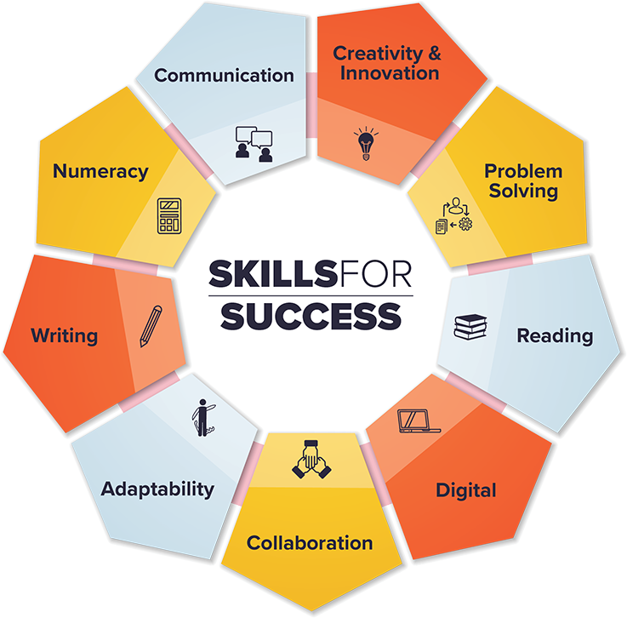
Figure 1: Essential Academic and Employment Skills [5]
Digital literacy is essential in today’s workforce due to rapid technological adoption. Vocational education must equip students with these skills. Research highlights best practices, challenges, and recommendations, emphasising teacher training, equitable technology access, and collaboration between institutions, industry, and policymakers to prepare students for successful careers in a digitalised labour market [6].
Numeracy skills are vital for employment and labour market success, as employers often use numeracy tests in recruitment, and improved numeracy increases job prospects. Poor numeracy can limit graduate employment opportunities across sectors, making the development of quantitative competence essential for workforce readiness and career advancement [7]

Task 1 (b): Evaluation of Task 1 (a) based on the Similarity report
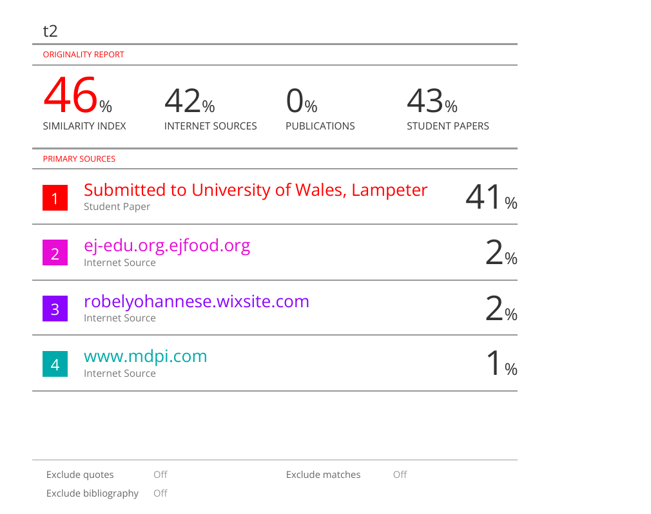

I received a 46% similarity score on my assignment. I have rechecked, and everything looks good on my end. The template I used showed 41% similarity, and I also received 5% similarity for my reference. Before writing this assignment, I read books on essential academic and employment skills from Google Scholar, and I also read many reports on this topic.
In regards to marking, I think I should get a 60% mark because I have done thorough research on this topic. I gave a brief introduction to my topic and explained the skills needed to succeed in both academic and employment careers. Then I discussed them one by one, drawing from multiple sources. I covered critical thinking from the book Critical Thinking Skills: Effective Analysis, Argument and Reflection; research ability from a report published by MDPI; and problem-solving from a research title, Employability skills: Problem solving in academic work, from the University of Leicester in 2025. Then I came to communication skills, writing from the book Communication Skills–Core of Employability Skills: Issues & Concerns. Later, for digital literacy, I read the book Digital Literacy and Vocational Education, which provided essential information about this. I have used a relevant picture about this topic.

Task 2: Collaborative Mind Map and Individual Poster

Mind Map (Collaborative)
Mind Map Link: https://mm.tt/map/3952545948?t=lDc7HHMFN2

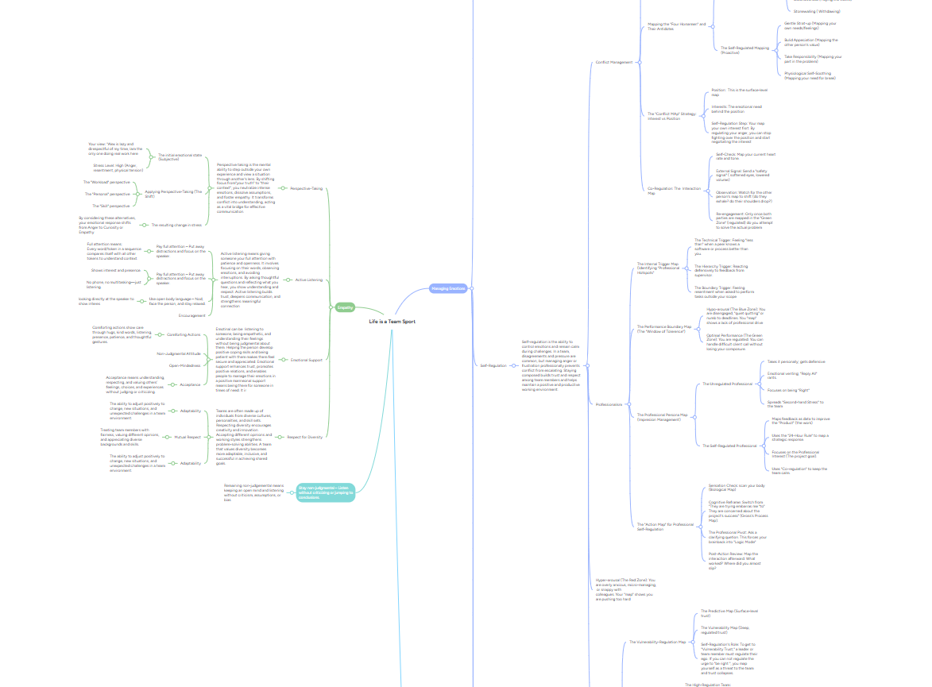

Poster (Individual)
Poster Link:
https://canva.link/veao84fn33b3n3t
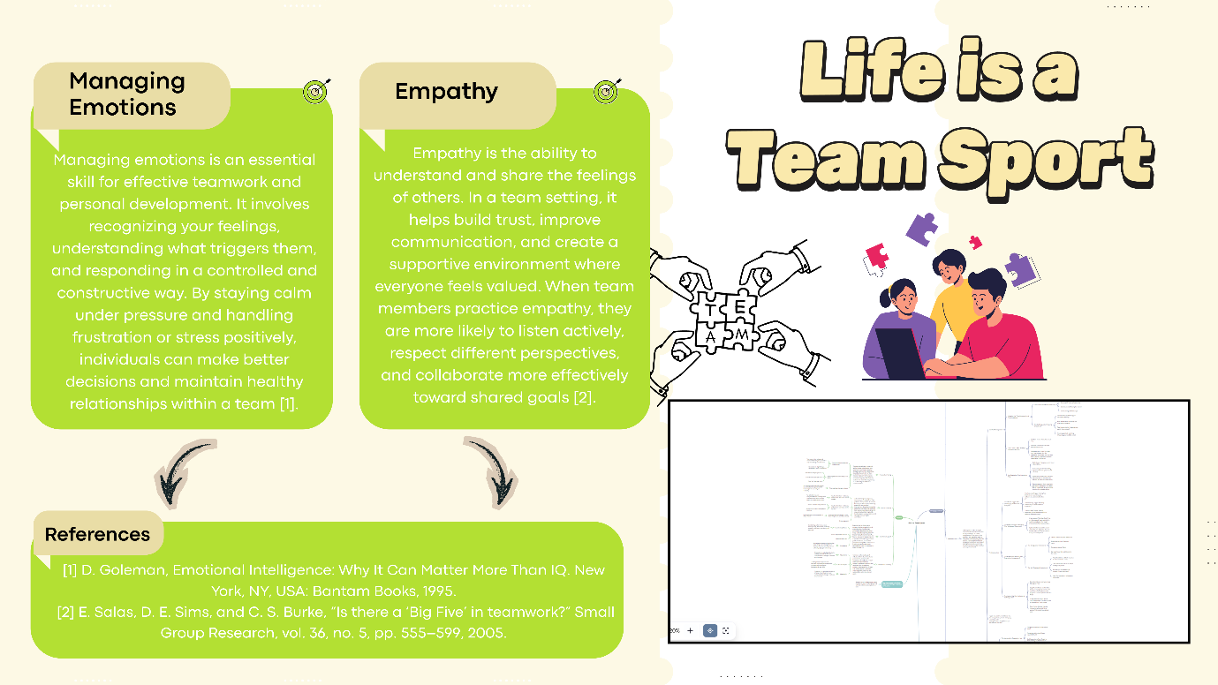

Task 3: Virtual Collaboration and RefWorks

Report on Virtual Collaboration

Unit 3: Topic 1 (Forming a team)
Virtual collaboration has become increasingly significant in modern workplaces as more teams work remotely or across different locations. Virtual collaboration refers to individuals working together using digital communication tools instead of gathering in the same physical space. Virtual team dynamics describe how the personal characteristics and behaviors of team members influence how they communicate, interact, and complete tasks in a virtual environment.
When a team is first formed, it usually goes through several stages of development. One well-known model is Tuckman’s stages of team development. These stages include forming, storming, norming, performing, and adjourning . In the forming stage, team members begin to get to know each other and understand the team's purpose. People may feel uncertain about their roles and responsibilities. During the storming stage, conflicts may arise because individuals have different working styles or opinions. In the norming stage, team members start to resolve differences, build trust, and work more cooperatively. Finally, in the performing stage, the team works effectively towards achieving shared objectives [1].
Trust plays a very important role in successful virtual collaboration. Without face-to-face interaction, team members may find it harder to build strong relationships. Research suggests that lack of direct interaction can sometimes lead to misunderstanding or distrust among team members. Building trust requires open communication, honesty, and reliability. When team members feel safe sharing ideas and asking for help, the team can perform more effectively [2].
One important concept related to trust is vulnerability-based trust. This occurs when individuals feel comfortable admitting mistakes, asking for help, or sharing concerns with others . When teams develop this type of trust, they often experience higher creativity, stronger collaboration, and better problem-solving [3].
Another key aspect of virtual collaboration is establishing clear goals. The FAST goal framework recommends that goals should be frequently discussed, Ambitious, Specific, and Transparent. Clear goals assist teams in staying focused and aligned while working together remotely [4].
Generally, effective virtual collaboration relies on trust, communication, clear objectives, and understanding the stages of team development. When these components are well managed, virtual teams can work efficiently and attain strong results.

Step-by-step process of using RefWorks with visuals
- We need to create an account on RefWorks.

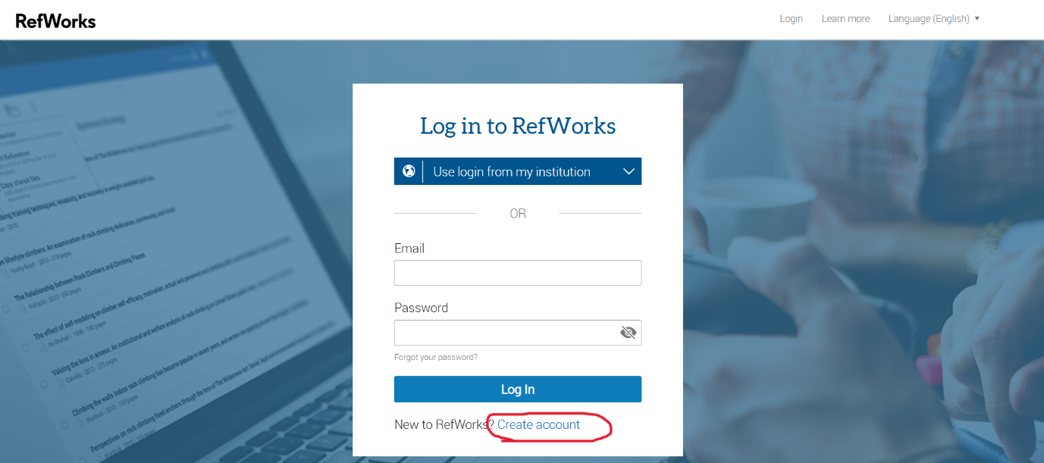

- We will create a folder.
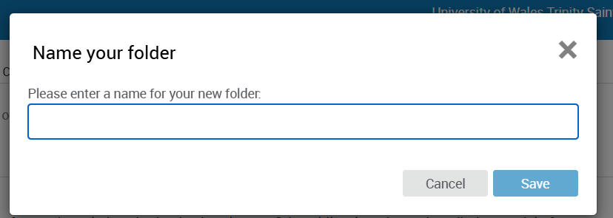

- Go to Google Scholar and search the topic on search bar. Google Scholar will then return the results.

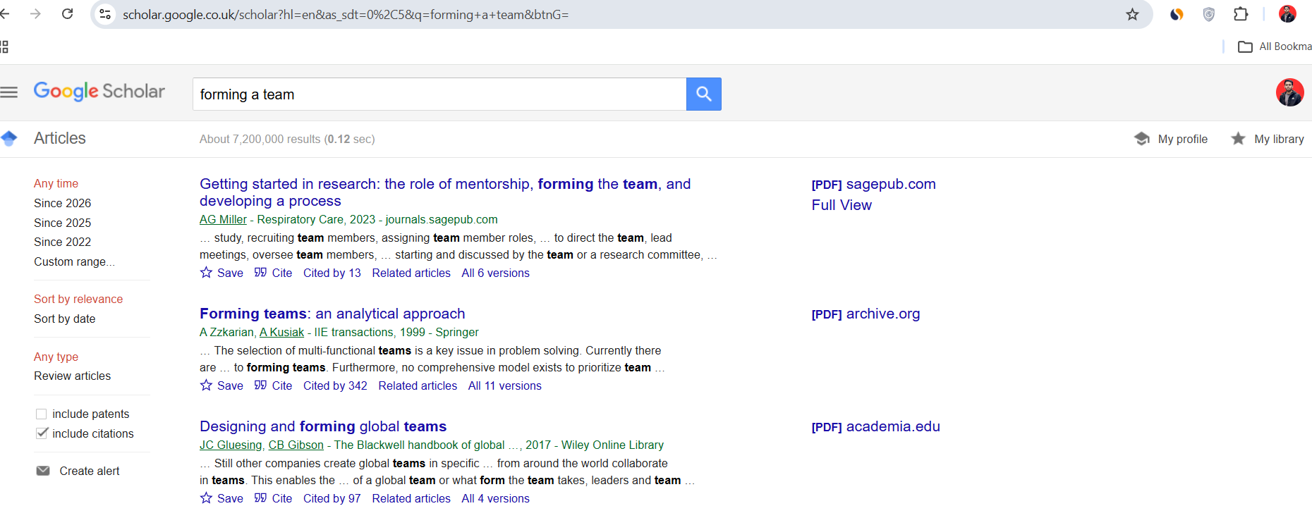

- At the bottom of all results, there is an option named "cite". There is an option to RefWorks; it will take you to the “RefWorks” website and ask you to choose a folder to cite. Then import it.
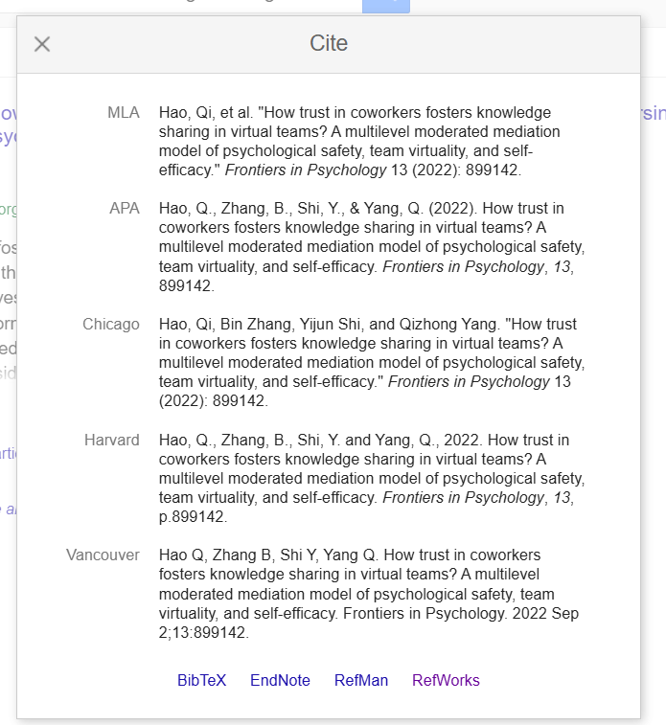

- Setting up RefWorks on MS Word. Do citation style to “IEEE UWTSD” . In “My reference” you will see all your references.
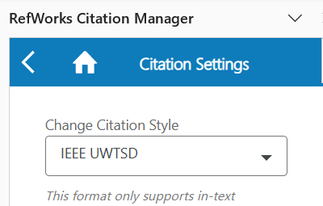

- To add your references, press your cursor on after the sentence and before the full stop. After that go “RCM” and chose your references and press insert citation.
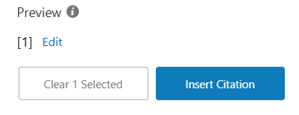

- After adding all references now its time for creating bibliography.
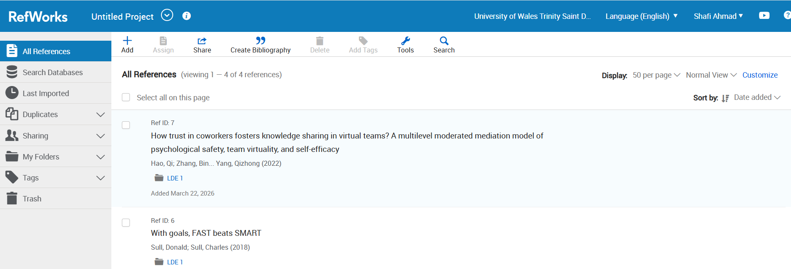

- After creating the bibliography, now it's time to copy it and check that the style is “IEEE UWTSD’.
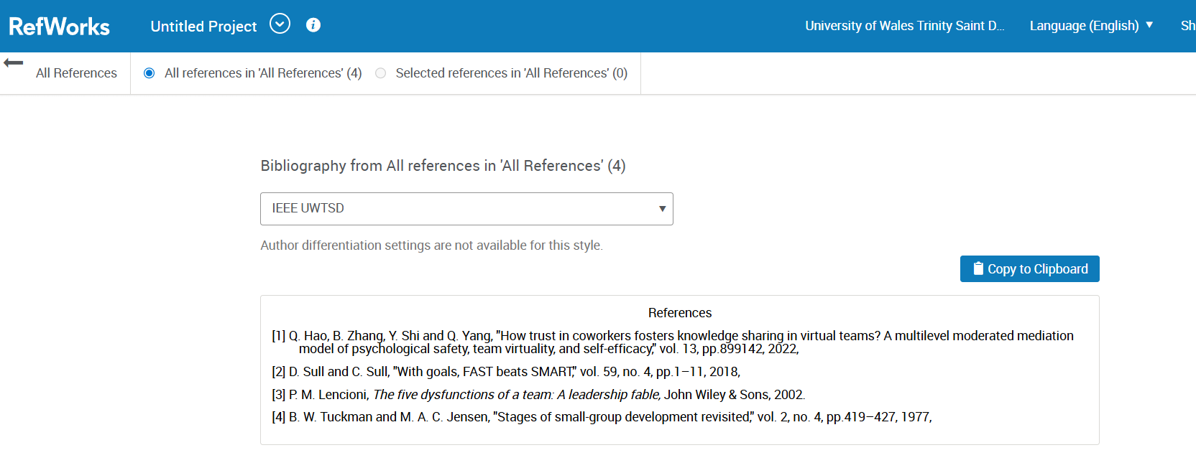

- Paste the bibliography on MS Words. That’s all.
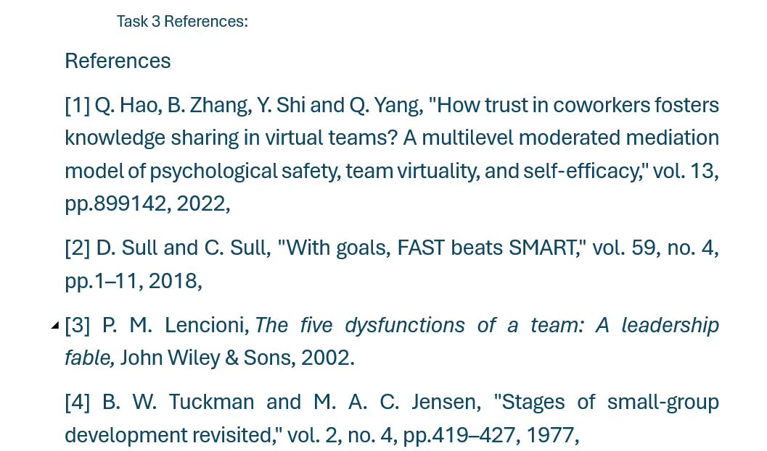

- Finally from RefWorks Citation Manager you can manage all your references and many more.

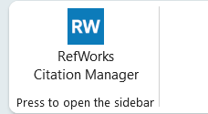

Task 4: E-Portfolio Creation and Evaluation

Task 4 (a): E-Portfolio Creation

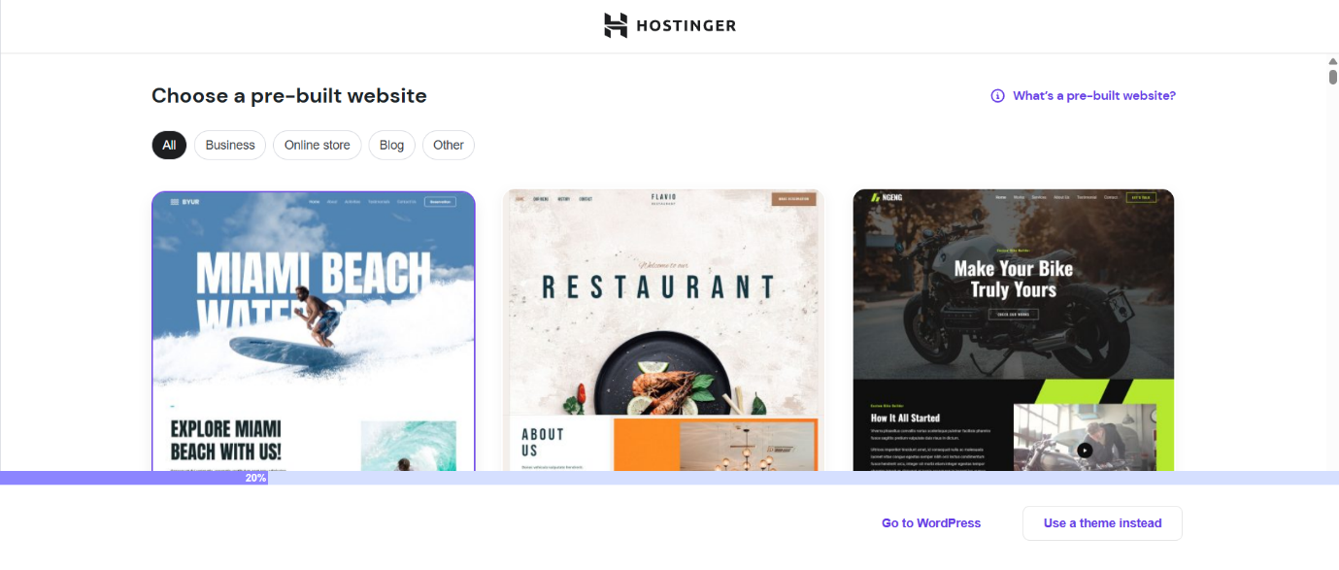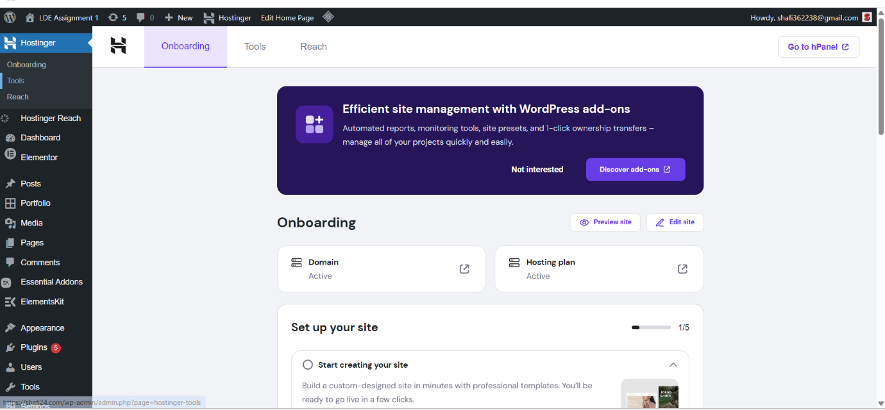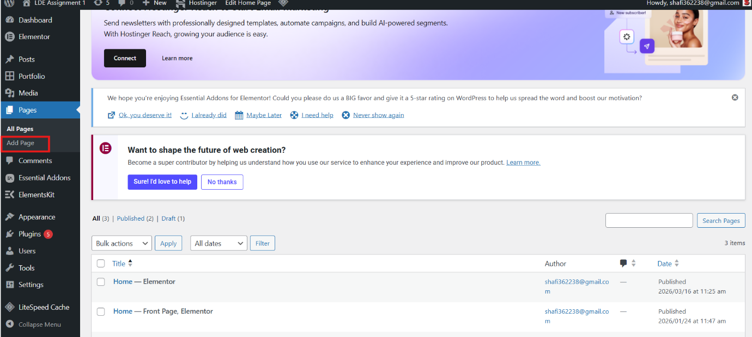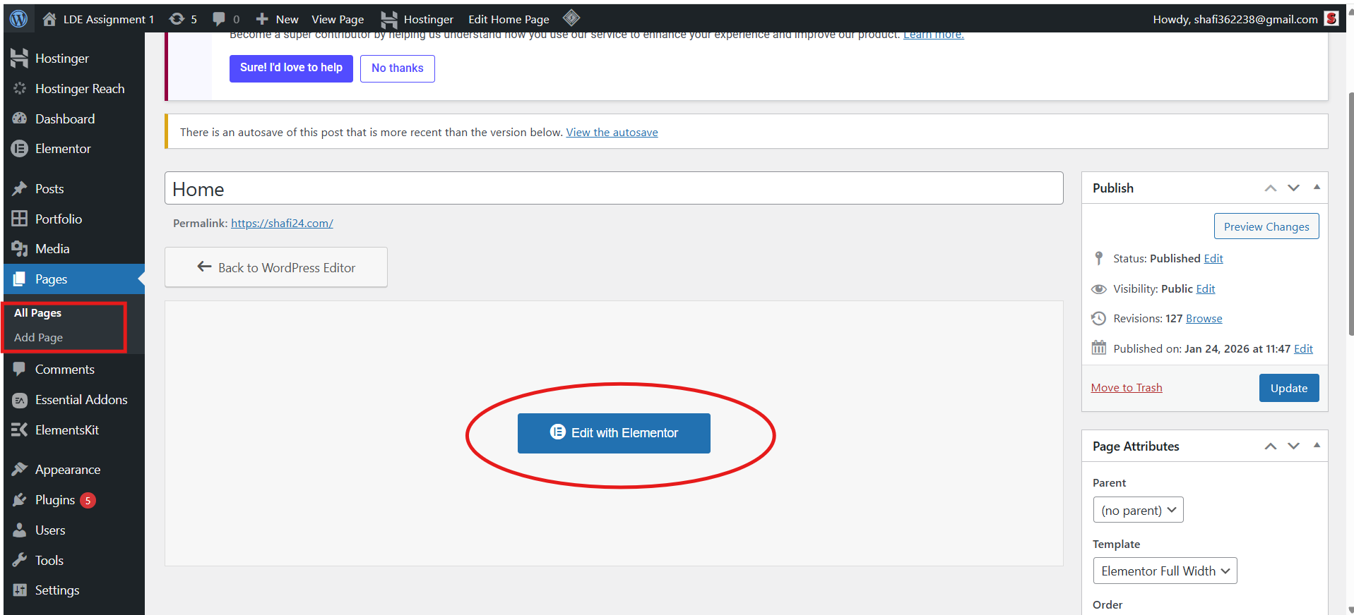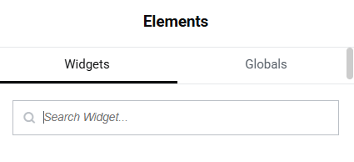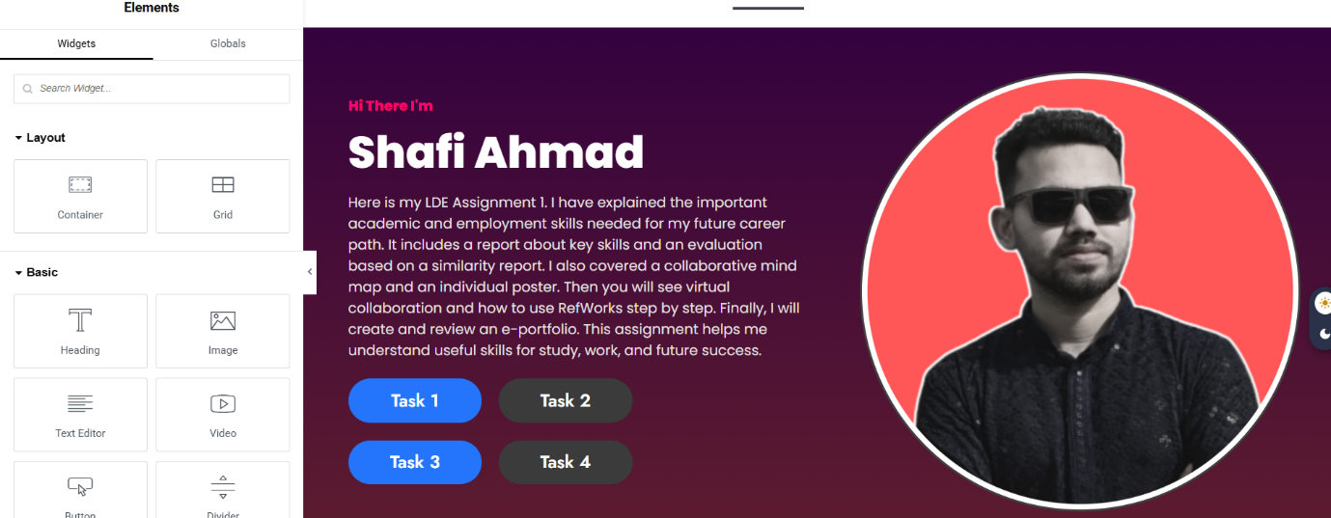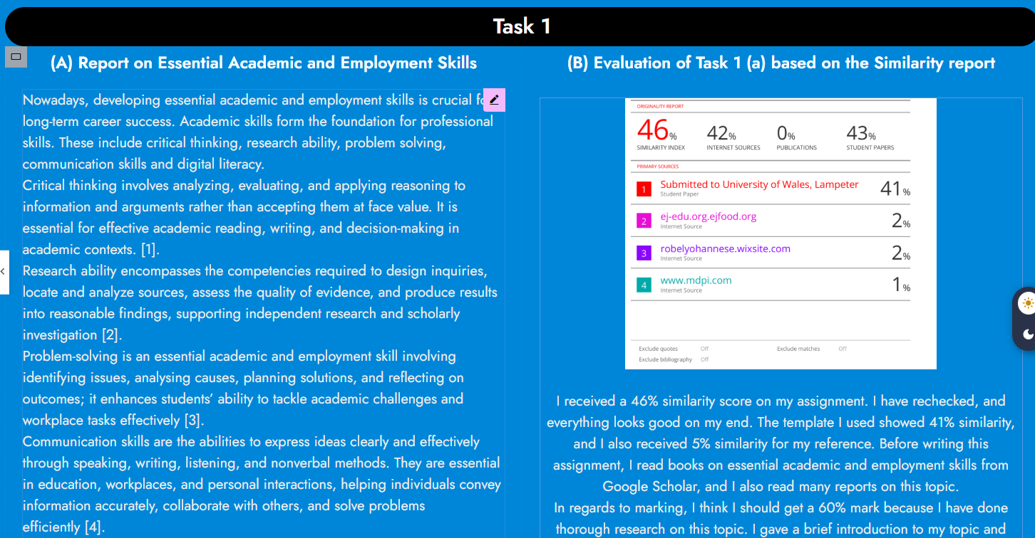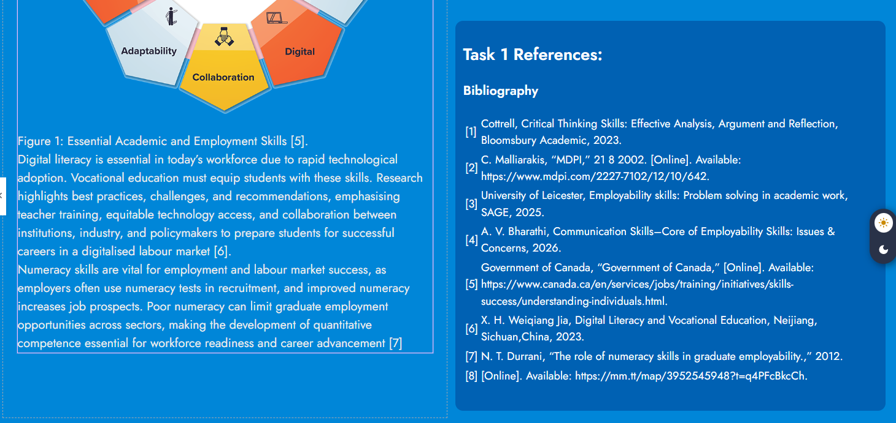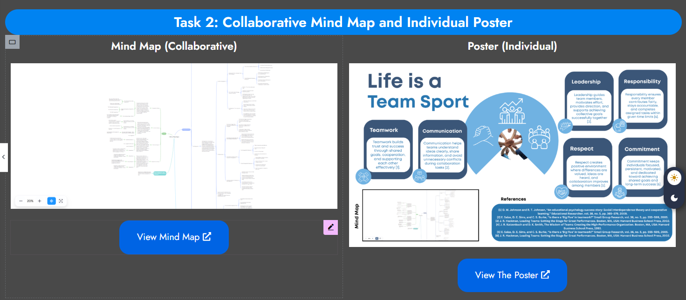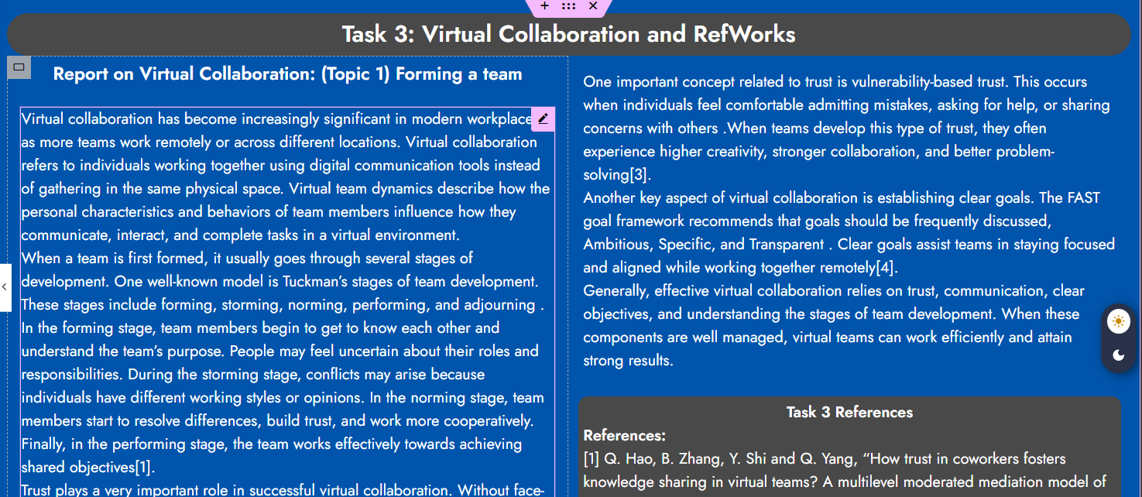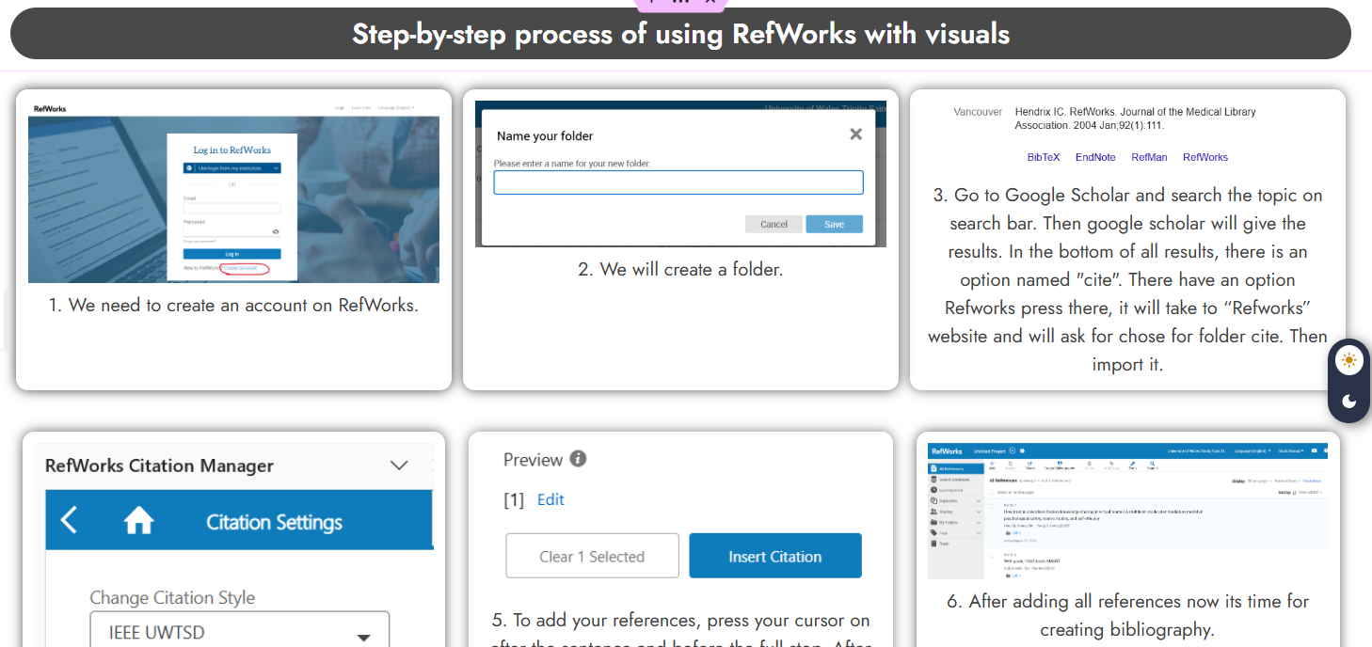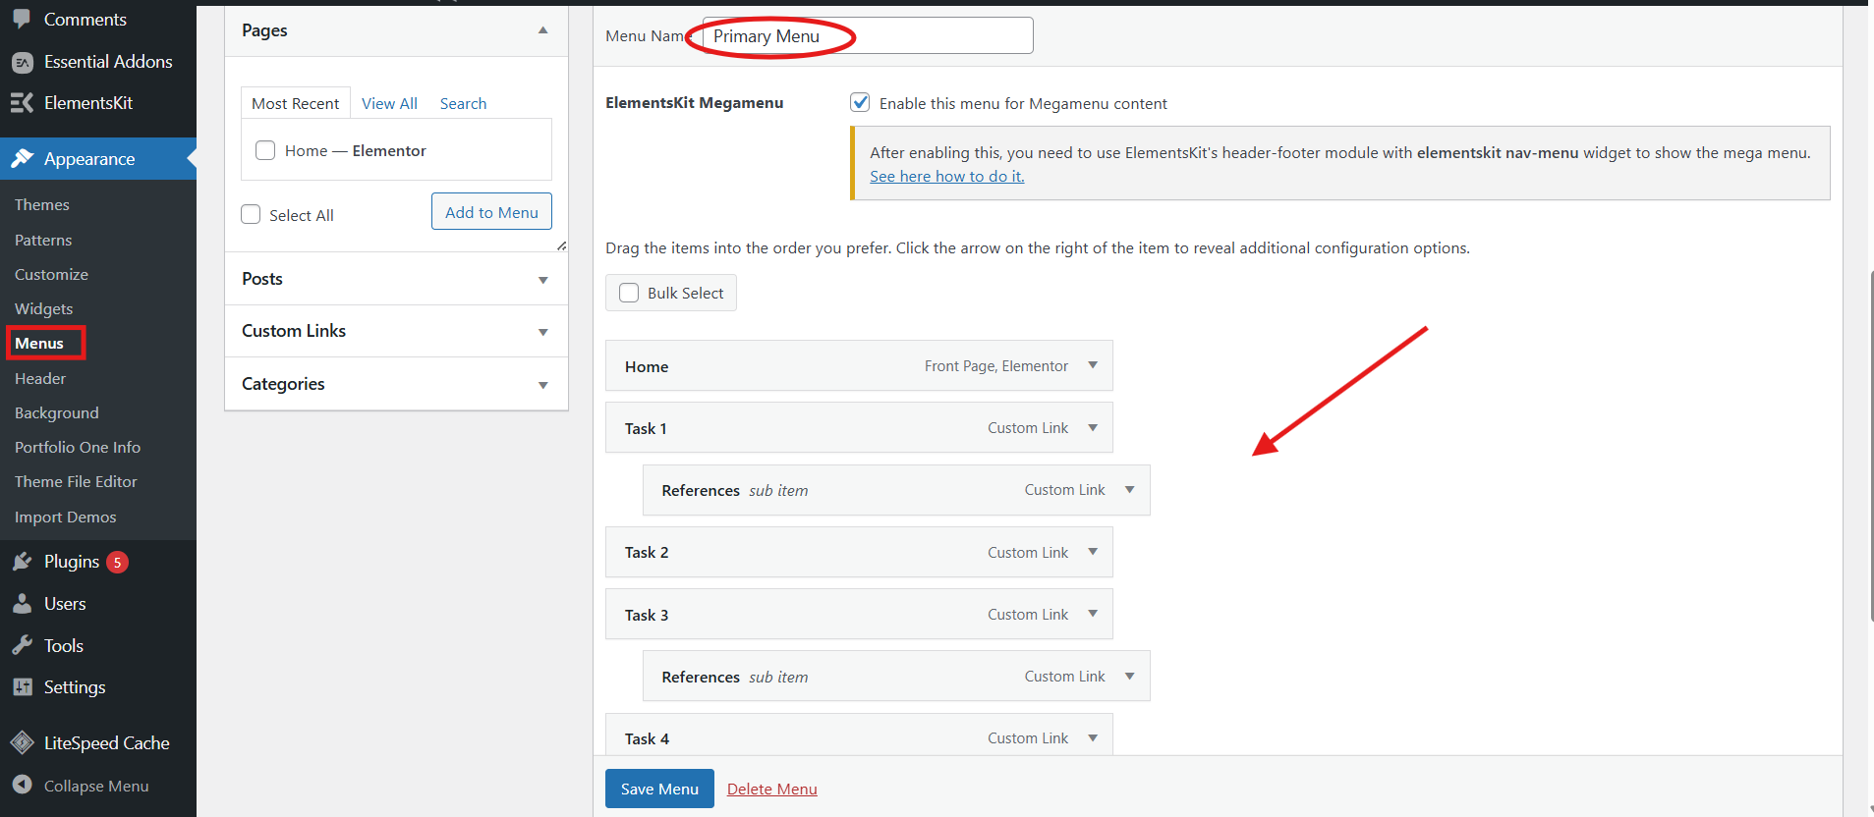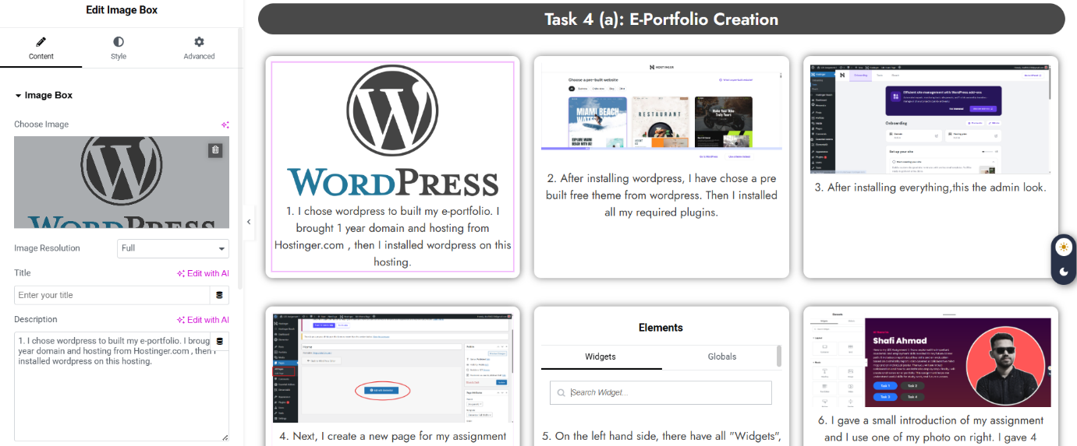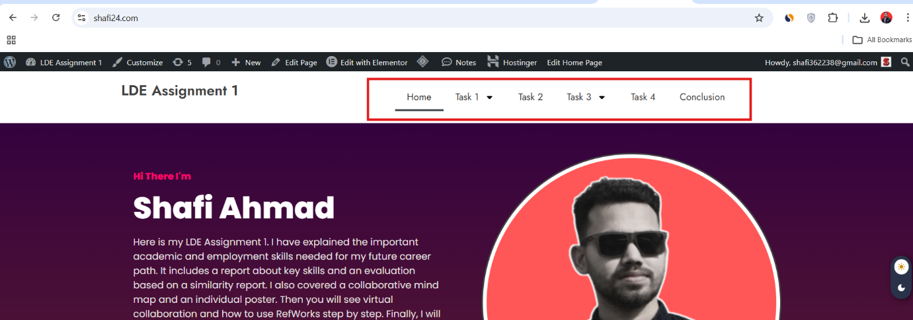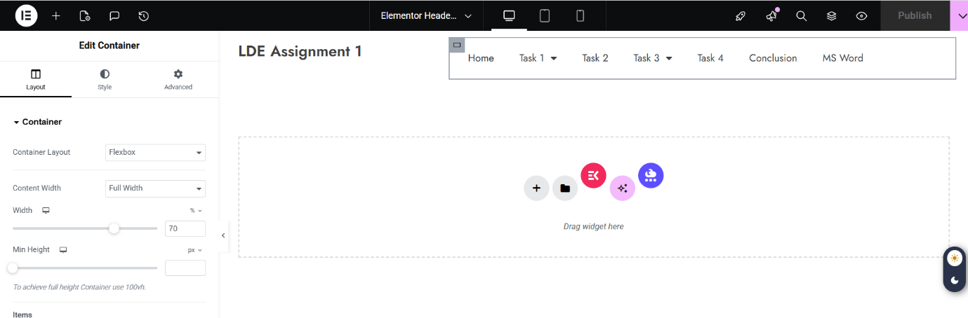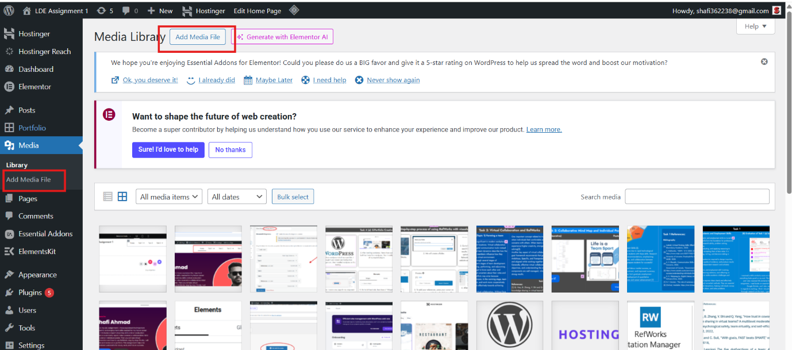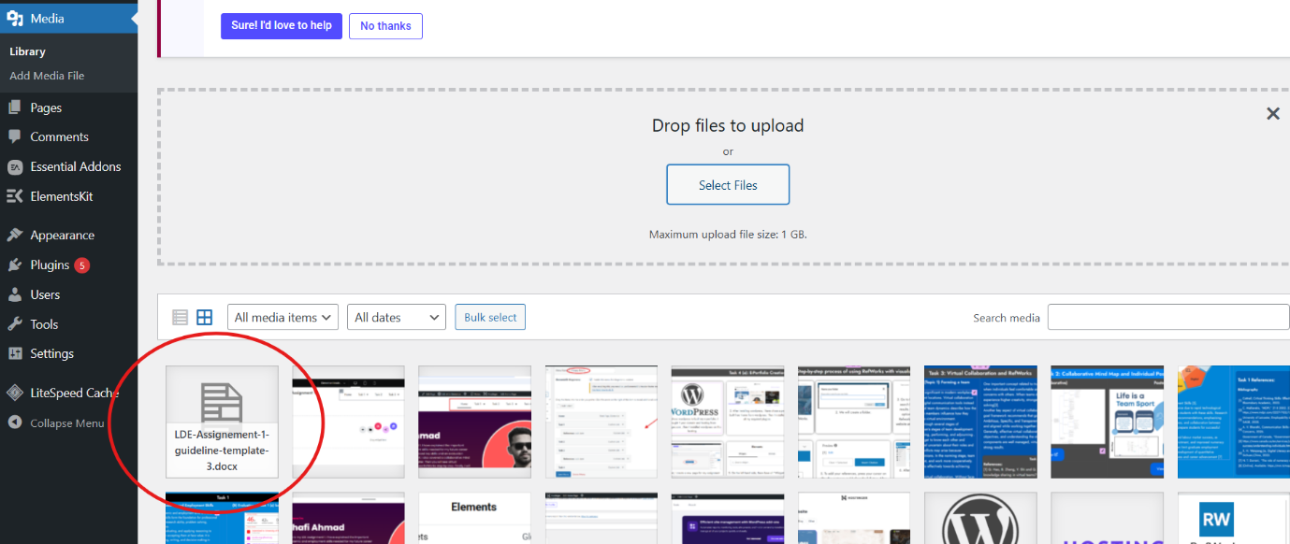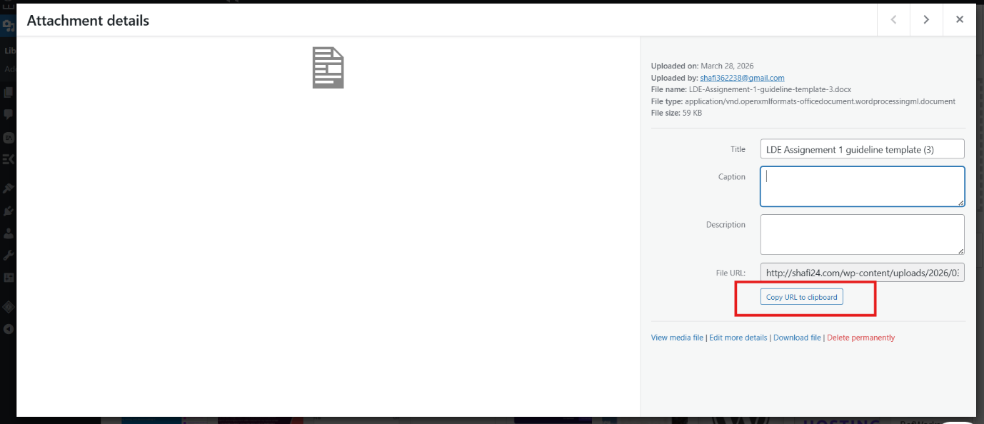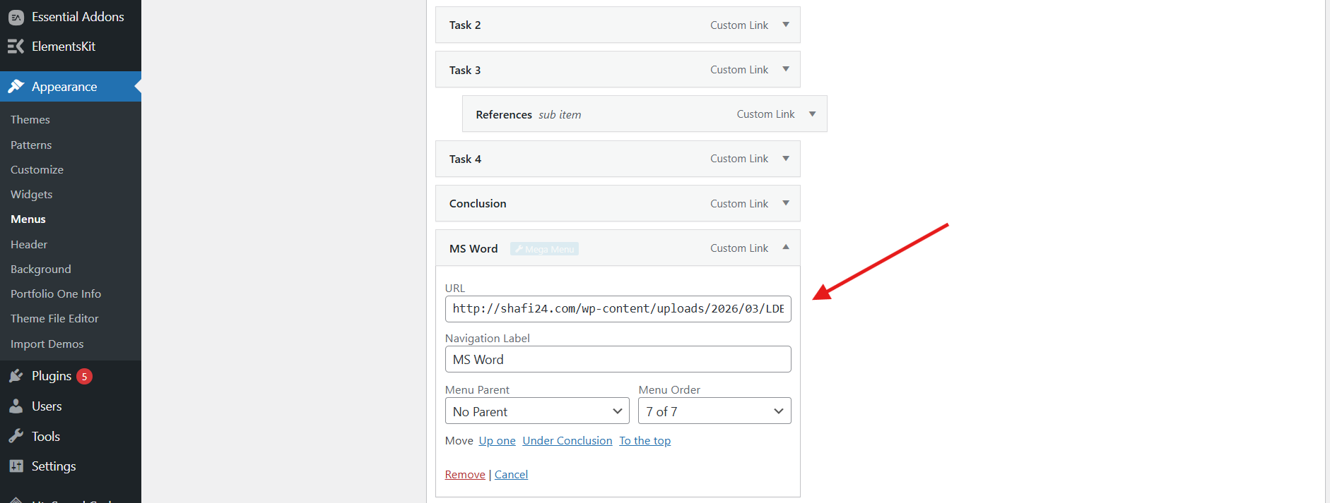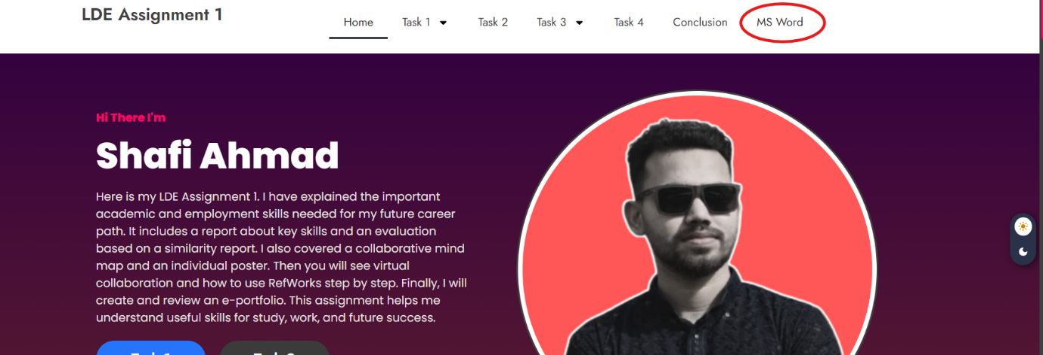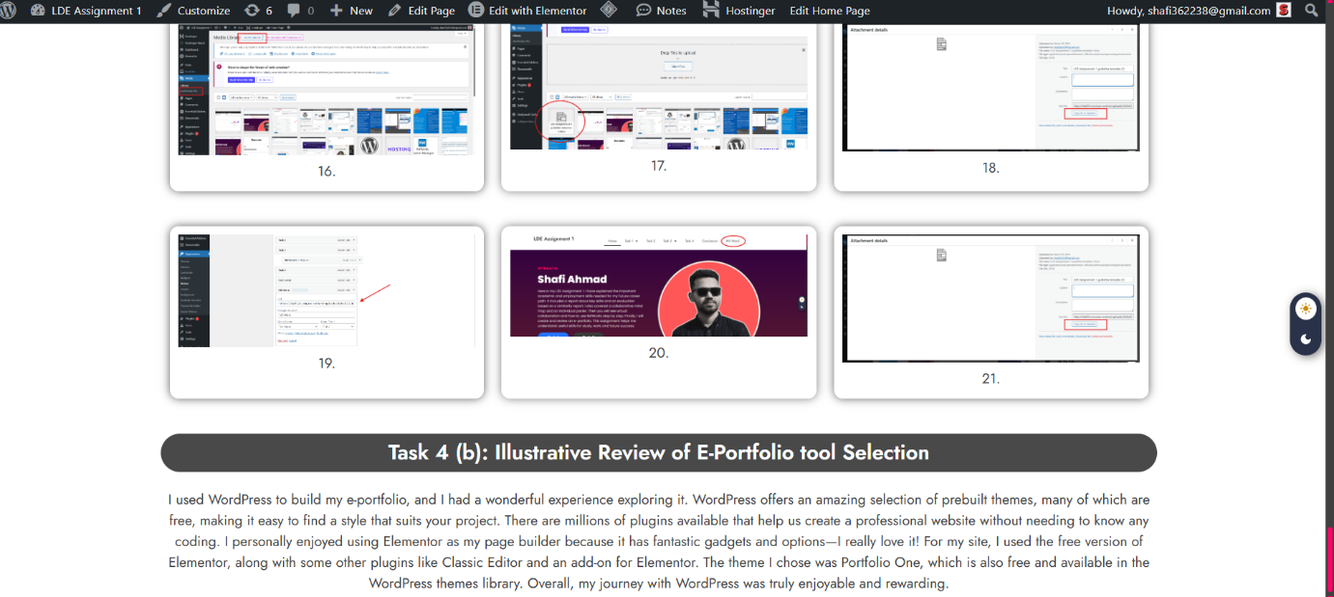

Task 4 (b): Illustrative Review of E-Portfolio tool Selection
I used WordPress to build my e-portfolio, and I had a wonderful experience exploring it. WordPress offers an amazing selection of prebuilt themes, many of which are free, making it easy to find a style that suits your project. There are millions of plugins available that help us create a professional website without needing to know any coding. I personally enjoyed using Elementor as my page builder because it has fantastic gadgets and options—I really love it! For my site, I used the free version of Elementor, along with the Classic Editor plugin and an Elementor add-on. The theme I chose was Portfolio One, which is also free and available in the WordPress themes library. Overall, my journey with WordPress was truly enjoyable and rewarding.

Conclusion
This assignment helped me understand the importance of essential academic and employment skills for my future career. I have also learned how skills like critical thinking, research, communication, problem-solving and digital literacy are important for both education and the workplace. I also gained experience in teamwork through the mind map and improved my creativity with the poster, which I designed by myself. The task on virtual collaboration and RefWorks improved my technical and research skills. Creating an e-portfolio using WordPress was a great experience. This assignment improved my knowledge, practical skills, and confidence, which will support my future academic and professional development.

References

Task 1 References:

Bibliography

[1] | Cottrell, Critical Thinking Skills: Effective Analysis, Argument and Reflection, Bloomsbury Academic, 2023.
[2] | C. Malliarakis, “MDPI,” 21 8 2002. [Online]. Available: https://www.mdpi.com/2227-7102/12/10/642.
[3] | University of Leicester, Employability skills: Problem solving in academic work, SAGE, 2025.
[4] | A. V. Bharathi, Communication Skills–Core of Employability Skills: Issues & Concerns, 2026.
[5] | Government of Canada, “Government of Canada,” [Online]. Available: https://www.canada.ca/en/services/jobs/training/initiatives/skills-success/understanding-individuals.html.
[6] | X. H. Weiqiang Jia, Digital Literacy and Vocational Education, Neijiang, Sichuan,China, 2023.
[7] | N. T. Durrani, “The role of numeracy skills in graduate employability.,” 2012.
[8] | [Online]. Available: https://mm.tt/map/3952545948?t=q4PFcBkcCh.

Task 3 References:

References

[1] Q. Hao, B. Zhang, Y. Shi and Q. Yang, "How trust in coworkers fosters knowledge sharing in virtual teams? A multilevel moderated mediation model of psychological safety, team virtuality, and self-efficacy," vol. 13, pp.899142, 2022,

[2] D. Sull and C. Sull, "With goals, FAST beats SMART," vol. 59, no. 4, pp.1–11, 2018,

[3] P. M. Lencioni, The five dysfunctions of a team: A leadership fable, John Wiley & Sons, 2002.

[4] B. W. Tuckman and M. A. C. Jensen, "Stages of small-group development revisited," vol. 2, no. 4, pp.419–427, 1977,

